A MULTIPURPOSE VACATION
We are so used to multitasking that nearly all our activities involve multiple goals. No different was my 2010 summer vacation: I set up and constructed my itineraries in such a way that each step along the journey would satisfy a need, or more than one if that was possible.
My trip contained essentially a threefold purpose: Grandma’s Marathon in Duluth, Minnesota, with a side-trip to visit Steven Reinemund in Minneapolis; a break in the trip to visit Switzerland and France to scout possible sites for next summer’s Roots and Roads student trip; my real vacation with the family that also included interviews with two “exchange students” one from the Budapest Cistercian, Dani Seidl, the other from Dunajska Streda, present day Slovakia, Ödön Örzsik, a cousin of mine three generations removed (his great-grandfather and my mother were siblings). Other visits were naturally also scheduled that included an unfulfilled appointment with my beloved Form Master from more 50 years ago, Károly Munkácsy, who unfortunately passed away while I was in Hungary—I was the last person to talk with him on his cell-phone while he was in the hospital.
- Grandma’s Marathon
I am convinced that each completed marathon (in certain cases even the ones that we were not able to complete for one reason or another) has a life of its own: it is conceived, nurtured, brought forth and fulfilled and eventually fades into oblivion with some residual memories. Some have relatives that will try to influence the existence of the outcome of later events.
Such thoughts were running through my mind as I first saw the advertisement for Grandma’s Marathon in Duluth. I had read many wonderful comments about this particular race, all highly complimenting its efficient organization, wonderful location and relatively easy course lay-out. The “relative” that knocked and wanted to be considered in this instance was a previously completed marathon, that of Boston in April of 2006. Of course everyone knows that the Boston Marathon is the “Grand-dad of all marathons” and for quite a while I was rather proud to have had the opportunity of participating in this elite event and proudly wore the finisher jersey and well designed, gray jacket that had imprinted in huge letters on the back “Boston Marathon 2006.” At the same time I also began to feel a certain amount of shame and uneasiness, since whenever I wore it, people in the know would mutter with a certain awe, almost reverently “you’ve run the Boston Marathon?!” since you don’t just register for Boston – you have to qualify. Well, I did not qualify: above and beyond the twenty plus thousand elite runners who do so, there are a few hundred numbers handed out for individuals who have otherwise “merited” consideration. I have raised funds for the research of the causes of MS, close to $25,000 on two separate occasions, so I was given the coveted badge. Yet my conscience kept bothering me, and for the last year or so I have abstained from wearing those highly desired insignia. Fortunately, as one ages, the qualifying times are somewhat relaxed, so I began to toy with the idea that I would want to merit that number that I have already usurped. For a male, pushing 70, an age that I was about reach, a time of “only” 4:30:59 is sufficient. Here is the deal: with my next marathon I will qualify, and whether or not I will or won’t run Boston again, I can with all justification wear the paraphernalia indicating that I indeed was a Boston finisher, with no “yes, but…” explanation.
My preps went well. I’ve curtailed my calorie intake, dropped my weight, increased my runs, along with my weight my pace went down, and I had every intention of qualifying at the next opportunity. Two major setbacks nixed this noble purpose: a prostate surgery with complications in November slowed me down tremendously. Within two months I was back again and improving. Even ran the Cowtown Ultra, not with a very good result, but gave myself the explanation that after all you just had major surgery… it will all come back. Here came Grandma’s. What better way to qualify for the “Grand-dad of all marathons” with qualifying time on Grandma’s Marathon. Pretty cool!
Again the training went well, nearly back to the previous peak of fairly easy 9 minute miles pace. Before the surgery I had run sub 9 minute 5K races like I used to do nearly ten years ago, results that gave me all the hope in the world that I would be successful. I started to attend to all the details a marathon involves. Besides the rigorous training I had make sure that I got to the place, had accommodations and a way back. My intention was to embed the race into my month long vacation. Since in the past, among the superiors (abbot, prior, sub-prior) of the monastery, according to our pecking order I was always the last one to take my turn, this time I obtained permission from Fr. Abbot to leave early – in mid-June, to fit in my marathon that was held on June 19. It actually worked out very well, since I had to be present at an official meeting of the Order in Hungary that was scheduled for late June.
Smooth sailing I thought: not so fast! Three weeks before the race I again had an unfortunate incident. Apparently not quite awake just yet in the morning while trying to take a shower, I accidentally kicked the side of my bath-tub, stubbing my little piggy next to the big toe of my left foot. Visit to the ER, X-rays—broken piggy, boot for my foot, no running! But a clean break, no floating particles anywhere, no surgical intervention needed. Approximate healing time: three to six weeks. Approximate time to Grandma’s Marathon: four weeks—so theoretically I could possibly still run by June 19th, but the most important phase of my final preparation has to be cut out altogether. Qualifying for Boston? Kiss it goodbye! Maybe, just maybe, I will be able to run, walk, crawl, pretend to run. I had not given up completely.
Without running life was a bit difficult, but I was definitely planning to make a go of it. Those pounds that stayed off easily while exercising started to make take their revenge. I struggled as time went on, but kept my hopes up. The morning of my departure for Duluth I went back to the foot specialist, had another X-ray taken and was given the news that if I could take the pain I no longer ran the danger of doing any more structural damage. Any marathon is a pain, so I went ahead and packed my bags.
Air-plane ticket in hand: Dallas, Minneapolis, Chicago, Zurich, Budapest for a paltry sum of $1,600 plus (ouch!) I tried to skimp on the costs of accommodations. Steven Reinemund, at whose wedding I officiated some years ago, lives in Minneapolis. Great! Since he is a runner I’ll invite him to join me and run Grandma’s with me. He declined the participation, but was more than happy to provide me with a private room and dinner the night of my arrival, and the same after the race. Rented a car at the airport, used my trusty GPS, found Steven and Cristina waiving in front of their house. Wonderful reunion, fabulous dinner. My arrangement in Duluth was similarly mendicant in style. Since Duluth is a fairly small town, I found out on the web that several local colleges were offering their dorms to participants for a reasonable price. The College of St. Scholastica, run by Benedictine nuns, was one of them. I immediately e-mailed them, telling them who I was, requesting information and opportunity to attend or celebrate Mass the next morning, that happened to be Fathers’ Day. Within a few hours I received a response from Mother Superior that they were actually looking for a priest to celebrate their community Mass that day, since their chaplain was on vacation. Where should they send the check for the Mass? What? No stipend for me; let’s take a quid pro quo, I’ll celebrate the Mass and you give me a room. Deal!
Still back in February I met a couple whose twin sons were to enroll at Cistercian in the fall, the FitzGeralds. Shannon and her sister Courtney (for her Grandma’s Marathon was to be the first one ever) were also flying to Minnesota the same day. We began to coordinate our itineraries. While we could not meet each other at the airport we did exchange enough information to find each other the evening before the race for a well prepared “pasta-party” that Shannon’s aunt was organizing. They had a house not more than a couple of miles from St. Scholastica’s. Even with my extreme geographically challenged status I was able to find the place and according to my usual custom began to socialize. Did I know that there used to be a Hungarian nun in the monastery who was quite an artist? Of course not, but it is always nice to find common ground, so I avidly inspected some of the artwork done by Sister Constantina that they possessed. Shannon also introduced me to her father. After a few informative questions and answers exchanged with Paul—small world indeed—we discovered that we were school-mates at Dallas Jesuit in the late fifties, he having graduated a year after I did, in 1961. Since then I looked him up in my yearbook and found him a bit changed after 50 years, but still recognized the kid I used meet in the old halls of Jesuit back on Oak Lawn in Dallas.
I would have loved to keep on socializing, but needed to return home to catch a good night-sleep before the marathon. I was wondering if I was going to have again my staple pre-marathon dream: a good number of times I dreamt that I was running a wonderful race, usually on PR pace (I mean really PR, like 7 minute pace!), then suddenly I would get lost, end up in the most bizarre places like in a museum or in a cathedral, or just in somebody dining room. This night was a peaceful, quiet, no nightmare night.
Early in the morning buses came by the campus and picked up the runners to take us the starting spot at Two Harbors. I forgot to make arrangements as to where to meet Shannon and Courtney, so while I was just milling about among the thousands of runners I was looking for the two people I had just met. I was not even looking at the faces, just try to see some recognizable sign, when I saw someone wearing a Dallas Turkey Trot T-shirt. I wanted to introduce myself and say that I was from Dallas, but scanning the face I realized that it was Courtney, Shannon’s sister who was approaching me. We decided to stick together. We knew that we would not be running very fast so we placed ourselves toward the back of the many thousands of runners, along the 12:00 mile group. It turned out even that was a bit too fast.
After the compulsory National Anthem and a very inspiring fly-over by fighter jets, we were off. It took us nearly ten minutes to get to the official starting mat, but we were chip timed, so it did not matter much that we did not get moving at the starting gun. For a while the three of us ran leisurely together, chatting and enjoying the scenery. After about three miles I had to slow down even more since my toe began to hurt. I bade good-bye to my friends, told them that I would meet them after the finish, and ever so slightly, but adjusted my gait to accommodate the aching toe. As it often happens, when compensating for one hurting body part, the others cry out for attention: my ankle started to complain. I held on for a few more miles, then stopped at a First Aid tent and requested some pain-killer. They provided me with some ibuprofen, but also took note of my number—in case they may need to rescue me later. On I went.
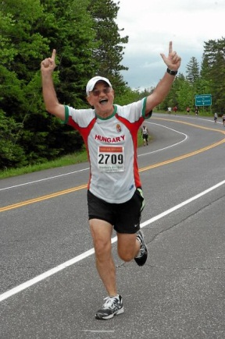
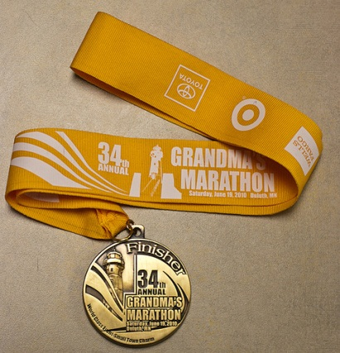
For the race I decided to wear my Hungary jersey, a very well designed, handsome piece of clothing, knowing fully well that I made myself target for some friendly ribbing. Sure enough: a good number of spectators cheered me on while shouting to me “Hungry?” I shot back: “Rather thirsty!” Smiling, I went on, accumulating mile after mile along the very beautiful shore of Lake Superior. The temperature was ideal by now, in the mid 50’s, hardly any wind; a bit overcast sky accompanied us toward the town of Duluth. A good number of us old-timers had settled into our routine trot, talking with each other, encouraging each other, hoping to finish. There were many photographers stationed along the way and their posts were rather conspicuously set up: as I approached them I made every effort to look really happy, and apparently succeeded since the photos taken at this race were some of the very best I had ever obtained. I am inserting a few of them into the text. The clock was approaching the 6:00:00 mark, but I was able to beat it by more than one minute: what an accomplishment at 5:58:41! My worst and my best! I had never run this slowly before, but neither have I finished a marathon with a broken piggy before! I was very happy to accept the hefty “Grandma’s Marathon finisher medal.” Of course qualifying for Boston had to wait. Yet I very quickly decided to keep on marathoning; I have already registered for the “Run the Rock” Dallas Marathon on December 5 and the Cowtown Ultra Marathon on February 27.
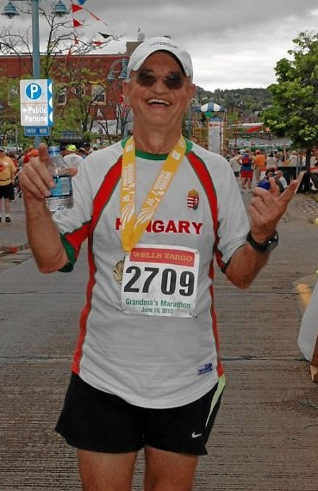
There was another, post-race party with the FitzGeralds. We told our stories, congratulated and commiserated with each other. Courtney had a rough first marathon, but she finished. Actually we all finished within a couple of minutes of each other, yet our paths never crossed as we mingled in the crowd. Went home, rested quite well, did not hurt any more than usually. I prepared for the next day’s activity: get ready with a homily for the sisters.
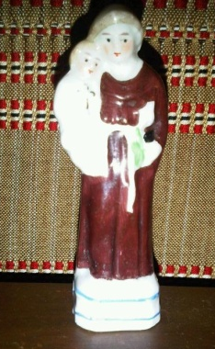
It was an easy feast to prepare: Fathers’ Day. At the beginning of the Mass I was introduced as Fr. Bernard (with accent on the wrong syllable) from Dallas. Anchoring my sermon on the words of Saint Luke’s Gospel (9:19) “Who do the crowds say that I am?” I began my homily with a rather odd sentence, saying that of the three statements in the introduction, i.e. father, Bernard, from Dallas, not a single one was really correct. I then qualified as to the sense of my “fatherhood” and proceeded to say a few words about the “hundredfold.” As to the name, I told them that my baptismal name is Anthony, and produced the little statue my mother gave me upon my leaving Hungary after the failed revolution in 1956. I briefly touched upon why Anthony (my mother’s vow to St. Anthony if the difficult pregnancy of her elderly years would result in a healthy offspring—in contradiction to her gynecologist’s suggestion that she have me aborted—if a boy, his name would be Anthony). Here I am, a healthy Bernard-Anthony. The show and tell had tremendous effect on my audience. I stayed with the nuns for lunch, then returned to Minneapolis for the evening.
- Minneapolis-Switzerland-France-Hungary
On my Blackberry I had registered my trips with a clever application called TripIt. It allowed me to follow my itinerary and it also alerted me automatically if there were any changes made to any of the flights. From the very beginning there were several. I received an odd note Monday morning (June 21) that due to inclement weather, my United flight #334 to Chicago was delayed, but I should still be at the airport as if the plane would leave at the normally scheduled time. While driving toward the airport I received another note stating that my flight was cancelled. When I showed up at the airport, the large board indicated that indeed my flight had been cancelled. Not finding any Information desk I lined up in front of the United counter and waited my turn. The clerk said that due to bad weather in Chicago the flight had been cancelled, and she could not get me there until the next day. I told her that it was unacceptable to me; please find another flight, since I had to catch a connecting flight to Zurich for which I had reservation. She was kind enough to make a couple of phone calls and I was confirmed on another flight with a different company that left within 15 minutes of my original flight. The trip was totally uneventful, arrived to Chicago that received us in brilliant sunshine, not a cloud in the sky, not a drop of rain anywhere. My conclusion: the United flight must not have been fully booked and it was more convenient to cancel, claiming inclement weather.
My flight to Zurich was more pleasant. Due to the good offices of Christine Schuepbach (an alumnus’ mom, Swiss national, who used to be a flight attendant with Swissair) I was given a seat in the business section. That’s the way to fly. My neighbor, Tom Heinz, was a very pleasant, retired gentleman from Chicago who was spending a couple of weeks in Switzerland and then was off with his wife and another couple to Hungary exactly at the same time I would also be in Budapest. We exchanged notes, made appointment to meet when they would come to the Hungarian capital. Indeed I spent a very pleasant evening with them after I finished my business in Switzerland and France.
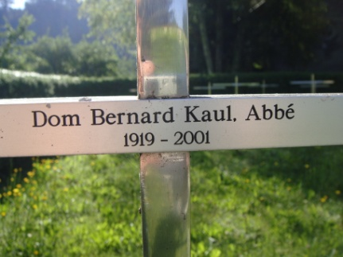
The reason for my stop-over in these two countries was that of business: since I am planning to take my class on a European trip next summer, I wanted to scout out the locations and visit each place I was planning to touch, so as to avoid any king of surprise, unpleasant or pleasant. My first stop was our monastery in Hauterive, located some 10 km. from the city of Fribourg. It was also a dear place for the Schuepbach family, since its old abbot was Dom Bernard Kaul, whom I met and befriended during our common stay in Rome while he was attending Vatican II, and I was a student residing in our General House. Actually it was Abbot Bernard who recommended our school to Christine and her husband Martin, I promised Christine that I would pray for her and her family. I was also considering of bringing the boys next year to visit this ancient monastery. I exchanged a few e-mails with Fr. Guest Master who informed me that I could either take a cab for about $45, or take the bus for one tenth of that sum.
I took the bus to Hauterive, to be more exact to Grangeneuve, the bus-stop serving the abbey. Upon getting off the bus I could only hear cowbells, saw nothing remotely resembling a monastery. After obtaining information from a passer-by I began my descent toward the buildings, carrying my rather heavy luggages. Eventually I found the entrance, with about a 100 step stairway leading down to the door. I first took one of my suitcases, dragged it down, went back for the other one and positioned myself in front of the large gate. I was wondering how I would get in when the gate opened automatically. I walked in and met Br. Gaston who showed me to my quarters, a very spacious apartment, apparently serving visiting dignitaries. I settled, met some more of the fathers and eventually Fr. Abbot as well. I followed their whole rigorous schedule, beginning with a 4:15 a.m. morning prayers, through the day and eventually evening, including their silent meals in their refectory. I will have a few more remarks later about the meals.
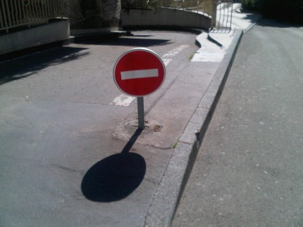
Early next morning I went to catch my train for Dijon. That is the city which figures prominently in the name of our order and its founding abbey, in Latin Cistercium, i.e. cis=on this side of, tertium=the third, the rest was left off “mile stone on the Roman highway leading to Dijon.” My train arrived at the main station fairly early before noon, so I proceeded with my pre-scheduled program. I have learned a great deal on this trip, especially learned lessons that I would avoid in the future. So mistake #1 to avoid: renting a car and trying to find the hotel downtown. The car I rented was a Fiat Panda, standard shift transmission. The web-site that allowed me to reserve the car stated, air-conditioning, unlimited mileage, cost of €86 per day. Rather steep price! What I did not expect was a bill that was immediately charged to our VISA account—the value of the euro was still very high in February—that resulted in a bill of over $100 with some extra charges to reflect the currency exchange. Still, I had the car, but it had no AC. Knowing how directionally challenged I was, I packed my GPS, fortified with a downloaded map of France. The Fiat had no cigarette lighter either, thus when the GPS ran out of juice I was at the mercy of old fashioned maps. My brand new GPS map also was not familiar with the latest versions of one way streets in Dijon and kept directing me to either the wrong way, or to a street that was recently made available for walkers only. I finally found the hotel after 48 minutes of driving around in circles, sometimes the same circle four or five times. Later on I found that the walking distance to the train-station was about 8 minutes. Of course there was the question of parking. When I finally checked into the hotel in the middle of the city, I asked the concierge about overnight parking: she told me that there were four public garages, each pretty much equidistant from the hotel. Sweating in the sweltering heat of the afternoon sun, I finally found the first garage with the “complet” sign flashing at the entrance—no available parking spaces. With much difficulty I found the next one that did not have any warning sign, but, unfortunately had two “entrances” with a rather ominous sign in the middle. This is what it looked like. Given the fact that the round plate faced more toward the right side, I decided to take the left entrance. Spiraling downward I ended up at a bar that would not raise itself—of course not; it was the exit. I had to get back out. The access was so narrow that turning around was out of question; let’s back out, upward. But where is the reverse? I knew that on some cars, like VW, you have to push on the gearshift lever down and out. Push I tried, no go. Pull I tried also nothing. Fiddling enough with the lever I found a little ring surround the knob. Naturally I tried to push first: still nothing. Once I grabbed the ring and pulled, voilà! I am in reverse.
All I had to do was to back all the way up. The Panda has a rather flat, boxy rear, and while the car points upward/backward you really cannot see a whole lot behind you, so I inched my way out. As soon as I got to sunlight I heard people shout at me: “arrête, arrête!” – I was heading directly into the “Do not enter” sign. I was on my way to Cîteaux. While the GPS had juice it directed me toward the town, but made me take the toll-road. When I realized that I had taken a huge detour and wanted to get off, it cost me over $5 just to exit. Eventually I found my way to the site of our ancient monastery that was a real downer for me. I knew that Napoleon had destroyed the original buildings, and also that a new church and buildings were constructed on the location, but the church especially left me unmoved. It had a low ceiling, too much light, and somehow it lacked the spirit I expected. Still, I made up my mind to bring the boys for a visit next year. I bought some authentic knick-knacks as souvenirs for my running friends: it was not so much the value of the small gift as the origin and the spiritual connection that I hope I can convey to the recipients as I hand them over.
Upon my return to Dijon I asked the desk clerk in the hotel if she had a train schedule, for I was to go back to Switzerland the next day. She nonchalantly responded that no, they did not have any, besides, I was not going anywhere tomorrow since there was going to be a railroad-workers strike the next day on most of the lines. Certainly no train to Fribourg! An brilliant idea hit me: with some luck I might catch a train to Lyon and visit Henri Brenders who had invited me to call on him in case I should ever go to France. I walked to the station (just about 8 minutes if you take the right direction—which I did not, so I ended up walking around for about an hour) and found out that there was ONE train that would leave for Lyon the next day at noon. Back at the hotel I dug deep into my documents pouch and found Henri’s phone number. I was able to get in touch with him and set up a meeting with him for the evening of the next day. I certainly hoped that the next day would bring me better luck.
Having finished my breakfast, by nine in the morning I made my way back to the station, deposited the car along with my complaints. The response to the lack of AC was that I should have ordered a larger car. As to the lack of cigarette lighter they had no explanation. I promised that I would lodge a complaint with the Avis headquarters, a threat I really did not want to follow through since it would cause me more trouble than the satisfaction of a half-hearted apology would have been worth. I walked over to the train station where a thousand people seemed to mill about. After waiting line for an hour and half I bought my ticket and arrived to Lyon without a hitch. I even got a reduced price for I was counted as a senior citizen.
I gave a call to Henri that I was at the station. He was in a meeting, but eventually called me back and instructed me to make my way to his school and he would show me around, then we would have dinner together. But first I had to find lodging since Henri did not offer me stay with him. I randomly began to survey the neighborhood, and walked into the first decent looking hotel I found. Of course they had no vacancy, but the concierge was very king and made some phone calls for me that resulted in a vacancy within walking distance. Would a hundred euros per night do? At this juncture most any price would have to do. I accepted, walked to the hotel and checked into a wonderful, old-fashioned, but air-conditioned suite. It was worth every penny. I took a cab to Henri’s school and we eventually found each other. He showed me every nook and cranny of a very impressive, large school that looked much different from the inside than it had from the outside. As we walked the streets of Lyon, looking for a feasible restaurant to satisfy our hunger, I saw a large Texas flag hanging in the window of one of the houses. I am sure it was one of our boys’ lodging that offered room for our Cistercian exchange students who happened to be spending their time in the city. Henri and I hit it off very well; we had a great dinner, walked some more in the city, then he drove me back home to my hotel. After all this was a rather pleasant little excursion that made me decide to bring the boys to Lyon next year.
After a good night’s sleep I took the train back to Fribourg and Hauterive. After a day’s travel I was rather tired, but even more hungry. I did not purchase any food, counting on some good monastic dinner once I returned to the abbey. To my great surprise, as we were picking up our utensils in the dining hall (that’s their custom: each member, upon entering the refectory, picks up his napkin and eating utensils, then goes to his place to consume his food) I noticed that besides me nobody picked up anything except their napkin. That was a bad foreboding sign! I did not realize that on Friday, the monks not only abstained (no meat) but they also fasted. They served us a slice of bread with rhubarb sauce and a cup of milk! The dinner was over very quickly, the prayers lasted much longer, but finally we retreated to our cells. My goodness, what was I to do? I could not go to the town to get some decent food, but my stomach kept on growling. Fortunately I still had some nutritious running supplements in my bag, so I squeezed a good amount of double caffeinated mocha gel tubes into my mouth and washed it down with plain water. At least I did not die of hunger.
I bade the monks good-bye the next morning. They wished me good luck and pleasant trip, but nobody offered to drive me to Fribourg or even to the bus stop. It took me almost an hour to drag my bags to the station. The bus was 15 early but fortunately so was I. Gladly I got on the train toward Zurich and the airport and was glad to have checked in onto our flight to Budapest that was only 30 minutes late. I called my niece and assured them that I would be home soon. Uneventful flight, both I and my luggage arrived promptly, and my family waited for me at the exit. I had already ordered my favorite Hungarian food so after the vicissitudes of my Swiss and French experience I was home free.
- Visit home and interview with two exchange students
Even though I have already spent nearly a week in Europe my jet lag was still happily with me. I was up by two in the morning and could not fall asleep until well after sunrise. In my boredom I raided the refrigerator that had become a habit of mine for the duration of my whole stay. When my sister first saw me she said that she did not like me skinny. Well, after a few days she must have liked me much more since I started to pack on the pounds rather quickly. I have set up my schedule to visit all my relatives: this time, instead of taking chunks of contiguous times one after the other, I dashed back and forth among them. It made them happy that they did not have to say a final good-bye when I left, knowing that I would be back for a second, perhaps a third time.
Between the visit to my brother and my niece I wanted to fit in a nice lunch with my former Form Master, Munkácsy Károly (I always called him Karcsi bácsi—uncle Charles). Our lunch would have taken place on Friday, but by Wednesday I received a phone call that he was not feeling well and had to be taken to the hospital to drain some fluid from his chest. But they expected him to back home within a week. I asked if I could call him: yes, Tuesday (July 13) around noon would be great. I made the call, got him on the phone, but I found his voice very weak. He did recognize me, answered briefly my few questions, then we hung up. The next day I was told that I was the last person who talked with him since he passed away peacefully during the night. I felt very touched and saddened. The family wanted me to stay for the funeral which was scheduled for a week later, but I could not change my plane ticket, thus I could follow his burial only through the internet. A wonderful educator and great friend has left us to join my many other friends in the afterlife.
I still had to meet Dani Seidl, our student from the Budapest Cistercian School who was to visit us in Dallas for a month. Both he and I were busy people, but we managed to meet at my sister’s home. I was well impressed with him and was glad to see him getting this award/reward for his outstanding performance in his school. Dani is presently (August of 2010) here in Dallas, staying with the Yoder family.
One more trip had to be scheduled: a visit to Csallóköz, ancient home of my parents, now part of Slovakia. I eagerly awaited this excursion since I had very pleasant childhood memories of the place. I rode the train, free of charge since I am over the age of 65 and also hold a Hungarian passport, to Győr. My cousin, Dr. Örzsik Ödön, came over the border to pick me up and drove me to his residence—a trip of less than an hour. It was the the doctor’s son, Ödi Jr. (or Eddy as he probably will be called, who will visit us in America and spend a year at our school. Obtaining a non-immigran visa for him was another saga that merits a disseration of its own.) After a very generous and fabulously tasty lunch we made our plans to visit most of the relatives in a whirlwind tour of just a few hours. We decided not to warn anyone of my arrival since we did not want to eat anywhere else; if they know that you are coming they will prepare a sumptuous feast for you and if you should refuse their hospitality it will be counted against you even worse than not visiting at all. Thus the whole enterprise entailed more than a few real surprises!
First we drove by the old house of my late uncle, now refurbished and beautifully kept by one of his grandsons. As we approached the lovely meadow neighboring the property I pointed out to Ödi a particular spot that used be a corn-field in the old days. I told him the story that at my last visit to this place in the summer of 1956 my cousin and I had the best lunch ever right there, consisting of roasted, fresh corn. I added that in order for the corn to taste really good it had to be stolen and roasted on open fire—running the risk of possibly getting caught. This was an indelible memory stuck in my mind. We made the rounds: first came a cousin who is older than I am, yet I am a generation earlier than she is. We simply knocked on her door, first sending Ödi’s children ahead. Openly irritated she did not want to let them in, thinking they were trying to sell her something, or worse, they were Gypsies—with whom she just had a very unpleasant encounter a few days earlier—then she first noticed Ödi, then me. Her jaw dropped, and she was breathless for nearly a minute. Obviously delighted she wanted to invite us in for “something to eat and drink.” Of course we declined, and within a few minutes we were off to our next round. With slight variations the scene followed the same script.
At last we came to the house of the cousin with whom I shared the stolen corn episode, Árpi Zirig. He is a former school teacher, now retired, a rather well known and published poet. The pretense to get him out of the house was that we came to show the new car that Ödi had recently bought. Half-heartedly he took the bait, but came to the door and then saw me—for the first time in many years. His delight was obvious. He warmly embraced me, then right on the spot he started to tell to the rest of the relatives congregating around us that his most fond memory he had of the two of us reached back to the summer of 1956—“you guys don’t realize how good roasted, especially just stolen ears of corn, taste!” Then proceeded to tell us that he had even written about the incident in a published novel and book of poetry. Wonderful visit with just a little bit of sherbet to show hospitality.
It was time to bid good-bye to the family and make my way back to Győr. The phone rang indicating that another cousin in Győr got word that I was around and he insisted that I stop by. I hadn’t seen his family in more than 25 years. When told that I absolutely had not time to make the detour to his house, he said that he would pack his family in the car and meet me at the border as we crossed back into Hungary. He also had a story that he remembered. He recalled that when Crown Prince Otto von Habsburg first visited Hungary in the late 70’s we happened to have been in the same small restaurant where Otto chose to eat lunch. Since the Prince had fist visited our monastery in Dallas I recognized him and told my cousin to take a look over there, close to us, I said, “hey cousin, that’s Otto von Habsburg.” Of course he did not believe me, so I said that I would go over and ask him if he really was who I thought he was. I wore my Cistercian-crested shirt, so I approached his Royal Highness and I asked him in English if he remembered having visited the US recently. With his think German accent, but impeccable English he said “but of course I do.” When further pressed whether he remembered having visited the Cistercian Monastery of Our Lady of Dallas—pointing to the crest on my shirt—he responded “but of course I do.” I further queried: “Then you are Otto von Habsburg, are you not?” “but of course I am.”—came the answer. I signaled to my cousin and my brother, Fr. Henry, to come over, so we introduced each other. Otto introduced his wife and his daugther, and I introduced Imi (the name of my cousin) and Fr. Henry. We chatted aimiably for a few minutes then we parted. This was the first time since the time of his exile and subsequent official renunciation of claims to the throne, that the Crown Prince had returned to Hungary. Imi immediately called his family, and told them what they obviously refused to believe. He also said that he would not wash the hand with which he shook hands with Otto von Habsburg.
As soon as I saw cousin Imi and his wife at the border crossing he immediately asked: “do you remember us meeting Otto von Habsburg nearly 30 years ago in the little restaurant?” But of course I did.
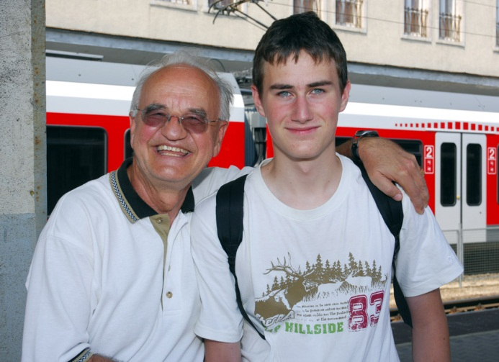
I had a couple more days of visits left, then had to prepare for my return to the States. My multipurpose vacation had just come to an end, but I had already recognized the seeds of some more, just as exciting adventures, that are certain to follow.
Ödi, the handsome, tall, blue-eyed young man, my cousin three generations removed, who has finally obtained his student visa, was ready to pack his bags and set out for America. He will be arriving on the first day of classes and move in first with the Squiers family, then with the Saads. He is very excited and is ready to embrace his Texan hosts.

